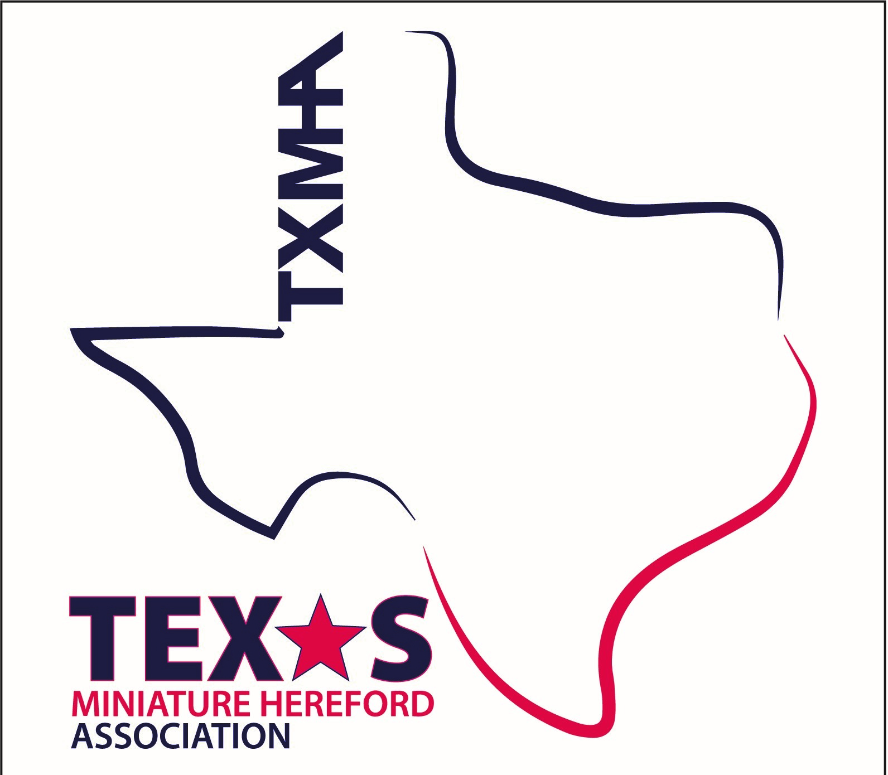
Texas Miniature Hereford Association

Membership Application

Membership will be active September 1, 2022 through August 31, 2023.
Memberships paid any time after September 1 will expire August 31, and sent a renewal letter.

NAME: _______________________________________________________________
(please list yourself and all members associated with this membership)

RANCH/BUSINESS NAME: _______________________________________________

ADDRESS: ____________________________________________________________
(where you receive mail)

RANCH/BUSINESS ADDRESS: ___________________________________________
(if different from above)

PHONE NUMBER: ____________________ CELL:____________________________

EMAIL ADDRESS: ______________________________________________________

Please indicate preferred method of communication for confirmation of membership.

Email: _________ Or Standard Mail: ____________

Annual membership is $75 yearly per family, ranch, or business entity. Associate membership is $100 yearly.
Memberships can also be paid online at www.txminihereford.org
. Please make checks payable to the Texas Miniature Hereford Association. Mail this form filled out and check to: TXHMA Treasurer – Attn: Thad Maples – PO Box 1447 Copperas Cove, TX 76522.

